Table of Contents
- Introduction
- Background to the Selected Area: Transportation
- Problem Statement
- Project Aim and Objectives
- Organization/Institution Background
- Problem Identification and Analysis
- Proposed Solution
- Scope of the Proposed System
- Stakeholders and Their Responsibilities
- System Requirements
- Business Rules and Ride Process
- Feasibility and Expected Benefits
- Dart Console Prototype
- Test Plan and Sample Test Cases
- Screenshot Evidence
- Explanation of the Program
- Limitations and Future Improvements
- Conclusion
- References

1. Introduction
Transport is an everyday service. People travel to work, school, markets, and appointments, and they need a safe, affordable, and predictable way to get there. In many cities, passengers find transport by waving down vehicles, negotiating prices on the roadside, and paying in cash. This can be slow, and the price and the driver are not known until the trip has already begun.
Ride-hailing software addresses this by letting a passenger request a trip, see an estimated fare, choose how to pay, and receive a confirmation that a driver has accepted. This project proposes SaloneRide, a Ride Booking and Payment System designed around the needs of passengers in Sierra Leone, including support for cash and mobile money payment.
For Assignment 1, SaloneRide is represented by a Dart console-based prototype. A console program is a suitable first step because it demonstrates the booking and payment logic without needing a mobile interface, map service, driver application, or payment gateway.
This document explains the problem, the context, the proposed solution, the system requirements, the business rules, the testing approach, and the behaviour of the prototype, and it includes the complete program source code.

2. Background to the Selected Area: Transportation
The selected area is Transportation, and in particular on-demand passenger transport. A ride service has several parts: passengers who need a trip, drivers who provide it, a way to agree the pickup point and destination, a way to agree the price, and a way to pay.
In a typical informal arrangement, a passenger finds a vehicle on the street, states a destination, and agrees a price with the driver. Payment is usually made in cash at the end of the trip. This arrangement is flexible, but it gives the passenger little information beforehand and leaves no record of the trip.
In Sierra Leone, mobile money services such as Orange Money and Afrimoney are available as an alternative to cash. A ride system that supports these options can give passengers more choice and can reduce the need to carry exact change.
The scenario in this report is a general example. It is not a claim that a named transport company has been formally investigated. If the assignment requires evidence from a real transport service, this section should be replaced or expanded with information gathered through an authorized interview or observation.

3. Problem Statement
Passengers who need transport often have to search for a vehicle, explain where they want to go, and negotiate a price. The final fare may depend on the driver's judgement, the time of day, or how the passenger looks, and the passenger often has no way to compare options before the trip starts.
Payment adds further difficulty. Cash requires the passenger and the driver to have suitable change, and there is no automatic receipt. When a passenger wants to pay with mobile money, the process is usually arranged informally between the passenger and the driver.
Because there is no booking record, it is also hard to confirm that a ride was requested, accepted, and completed. Passengers who travel at night or to unfamiliar places may feel uncertain about whether a driver will be found.
Therefore, there is a need for a ride booking and payment system that allows a passenger to request a ride, see an estimated fare, choose a payment method, and receive confirmation that a driver has accepted. The proposed SaloneRide system demonstrates these functions through a Dart console-based prototype.

3.1 The Main Problem in One Sentence
Informal ride arrangements give passengers no advance fare, no booking confirmation, and limited payment choice.

3.2 Why the Problem Matters
Transport affects access to work, education, healthcare, and markets. A clearer booking process, a visible fare, and a choice of payment method make the journey easier to plan and give the passenger more confidence. Software does not replace the need for safe driving and fair pricing rules, but it can make the booking and payment steps clearer.

4. Project Aim and Objectives

4.1 Aim
The aim of SaloneRide is to design and demonstrate a simple software system that lets a passenger request a ride, see an estimated fare, choose a payment method, and receive confirmation of the trip.

4.2 Specific Objectives
- To create a passenger profile using a name and phone number.
- To allow a passenger to request a ride by entering a pickup location and destination.
- To display an estimated fare before the trip begins.
- To let the passenger choose between cash, Orange Money, and Afrimoney.
- To represent a ride as a record that has a pickup, destination, fare, payment method, and status.
- To simulate driver acceptance and trip completion.
- To simulate payment, including a mobile money PIN prompt for electronic payments.
- To demonstrate basic software engineering practices such as classes, control flow, testing, and documentation.
- To provide a foundation that can later be extended into a Flutter application with real maps, drivers, and payments.

5. Organization/Institution Background

5.1 Type of Organization
The system is intended for a ride-hailing or passenger transport service operating in a city such as Freetown. The service connects passengers with drivers, calculates fares, and collects payment.

5.2 Main Activities
- Registering passengers and drivers.
- Receiving ride requests with pickup and destination.
- Estimating the fare for a trip.
- Matching a request with an available driver.
- Tracking the status of a ride from request to completion.
- Collecting payment by cash or mobile money.
- Handling enquiries and complaints.

5.3 Department Where the Problem May Occur
The problem would mainly affect the operations and customer service functions of the transport service, where requests are received and trips are coordinated, and the finance function, where payments are recorded. The exact structure depends on the organization.

5.4 Existing Method in the Proposed Scenario
For this scenario, assume that passengers find vehicles by hand signal or by phone call, agree the fare verbally, and pay in cash or by sending mobile money directly to the driver. Trips are not recorded centrally, so the organization has no complete list of requests, fares, and payments.
This is an example of a possible current process, not a verified statement about a specific organization. A real investigation should confirm how requests and payments are actually handled.

5.5 Why the Organization Needs Improvement
A booking system that records each ride, shows an estimated fare, and supports several payment methods would help the organization keep consistent records and give passengers a clearer experience. The first prototype demonstrates the core booking and payment flow without claiming to be a complete ride-hailing platform.

6. Problem Identification and Analysis

6.1 Causes
- Fares are agreed verbally and are not shown in advance.
- Requests are not captured in a central record.
- Cash is the main payment method, which depends on change being available.
- Mobile money payments are arranged informally.
- Passengers receive no confirmation that a driver has accepted a trip.
- Trip details such as pickup and destination are not stored.

6.2 Effects
- Passengers cannot easily compare or predict the cost of a trip.
- Disagreements about fares can arise during or after the trip.
- There is no receipt or history of trips and payments.
- Passengers may be unsure whether a driver is on the way.
- The organization cannot easily review demand or revenue.
- Payments that are not recorded are harder to confirm later.

6.3 Stakeholders Affected
Stakeholder | Interest or responsibility | Possible effect of the problem
Passengers | Need a reliable, clearly priced ride. | May face uncertainty about price, availability, and payment.
Drivers | Provide trips and receive payment. | May have disputes over fares and depend on cash and change.
Operations staff | Coordinate requests and trips. | May have no central record of requests and ride status.
Management | Oversee service quality and revenue. | May lack data on trips and payments.

6.4 Current Process Compared with the Proposed Process
Activity | Possible current process | Proposed SaloneRide process
Register | No formal passenger profile. | Enter a name and phone number to create a profile.
Request a ride | Wave down a vehicle or phone a driver. | Enter pickup location and destination in the program.
Know the fare | Negotiate verbally. | Estimated fare is displayed before the trip.
Choose payment | Usually cash, or arranged informally. | Choose Cash, Orange Money, or Afrimoney.
Confirm a driver | No confirmation until a vehicle stops. | Ride status changes to Accepted and is displayed.
Pay | Hand over cash or send money separately. | Cash instruction or a simulated mobile money payment.

The console prototype is an initial demonstration. The driver search, fare, and payment are simulated, and the data is temporary, so it does not yet replace a real ride-hailing platform.

7. Proposed Solution

7.1 Name of the System
SaloneRide: Ride Booking and Payment System.

7.2 Description
SaloneRide is a proposed software system that lets a passenger create a profile, request a ride, see an estimated fare, choose a payment method, and receive confirmation. Each ride is represented as a record containing the pickup, destination, fare, payment method, and status.
For Assignment 1, SaloneRide runs as a Dart console program. The passenger enters their details, then uses a menu to request rides or exit. Driver acceptance and payment processing are simulated so that the whole flow can be demonstrated in one run.

7.3 Proposed Users
User | Assignment 1 prototype | Role in the complete system
Passenger | Creates a profile, requests a ride, selects payment. | Request rides, view fares, pay, and review trip history.
Driver | Simulated: the program automatically accepts the ride. | Receive requests, accept or decline, and complete trips.
Administrator | Not included. | Manage users, fares, and payment records.

7.4 Main Features
- Passenger profile with name and phone number.
- Main menu with Request a Ride and Exit options.
- Entry of pickup location and destination.
- Estimated fare displayed before the trip.
- Payment choice: Cash, Orange Money, or Afrimoney.
- Ride record with status (Pending, then Accepted).
- Simulated driver search, trip, and arrival messages.
- Cash instruction, or a mobile money PIN prompt and confirmation.
- Multiple rides in one session until the user exits.

7.5 Expected Benefits
- A clear, repeatable booking process.
- The fare is shown before the trip.
- Passengers can choose a familiar payment method.
- Each ride is represented as structured data.
- A foundation for later maps, driver matching, and real payments.

8. Scope of the Proposed System

8.1 Included in Assignment 1
- Creating a passenger profile with a name and phone number.
- Requesting a ride with a pickup and destination.
- Displaying a fixed estimated fare.
- Choosing a payment method.
- Creating a ride record and simulating driver acceptance.
- Simulating trip progress, arrival, and payment.
- Repeating the request flow until the user exits.

8.2 Not Included in Assignment 1
- A driver application or real driver matching.
- Maps, GPS tracking, or distance-based fares.
- Real connection to Orange Money, Afrimoney, or any payment service.
- Passwords, login, or account verification.
- Permanent storage of passengers or rides.
- Ratings, receipts, trip history, or cancellation.
- Safety features such as emergency contacts or trip sharing.

8.3 Assumptions
- The currency is the New Leone (NLE).
- The estimated fare in the prototype is a fixed value of NLE 50.00, used for demonstration only.
- A driver is always found and accepts the ride immediately.
- The prototype uses sample data and is not intended to store real personal information or real payment details.
The fare and payment options should be changed if the organization provides an official pricing policy or payment arrangement.

9. Stakeholders and Their Responsibilities
Stakeholder | Responsibilities in the proposed system
Passenger | Provide accurate pickup and destination details, choose a payment method, and pay for the trip.
Driver | Accept requests, complete trips safely, and receive payment.
Operations staff | Monitor requests and ride status and respond to passenger enquiries.
Finance staff | Reconcile cash and mobile money payments with ride records.
System administrator (future) | Manage accounts, fares, permissions, backups, and technical maintenance.
Management | Approve pricing and payment policies and procedures for protecting personal data.

The Assignment 1 prototype does not implement these roles as separate accounts. The table describes the intended users of a fuller system.

10. System Requirements

10.1 Functional Requirements
Functional requirements describe actions the system must perform. Each can be checked by running the program.
ID | Requirement | Acceptance check
FR01 | The system shall collect the passenger's name and phone number. | The program prompts for both and accepts the entries.
FR02 | The system shall create a passenger profile and display a welcome message. | The message shows the entered name.
FR03 | The system shall display a main menu with Request a Ride and Exit. | The menu appears after the profile is created.
FR04 | The system shall collect a pickup location and a destination. | Both prompts appear after choosing option 1.
FR05 | The system shall display an estimated fare before payment is chosen. | The fare is shown in NLE.
FR06 | The system shall offer Cash, Orange Money, and Afrimoney as payment methods. | All three options are listed.
FR07 | The system shall use Cash when the payment choice is not 2 or 3. | Enter 9; the payment method becomes Cash.
FR08 | The system shall create a ride record and set its status to Accepted. | The status message shows Accepted.
FR09 | The system shall display trip progress and arrival messages. | The pickup and destination appear in the trip message.
FR10 | For cash, the system shall display an instruction to pay the driver. | The cash message shows the fare.
FR11 | For mobile money, the system shall prompt for a PIN and confirm payment. | A PIN prompt and a success message appear.
FR12 | The system shall return to the menu after a ride is complete. | The menu is shown again; another ride can be requested.
FR13 | The system shall handle an invalid menu choice without terminating. | An error appears and the menu is shown again.
FR14 | The system shall allow the user to exit. | Choose 2; a goodbye message appears and the program stops.

10.2 Non-Functional Requirements
ID / Quality | Requirement | How it can be assessed
NFR01 - Usability | Prompts and menu labels should be clear and include examples. | A user can complete a ride without reading the code.
NFR02 - Reliability | Invalid menu choices should not crash the program. | Enter unsupported options and observe the menu.
NFR03 - Maintainability | Passenger and ride data should be defined as classes. | The code contains Passenger and Ride classes.
NFR04 - Performance | The prototype should respond immediately to normal input. | Run a full ride and observe no delay.
NFR05 - Security | A deployed version must never store or display a real PIN, and must use a secure payment provider. | Future work; the prototype only simulates a PIN.
NFR06 - Privacy | Real phone numbers and locations must be protected. | Use sample data in the prototype.
NFR07 - Scalability | The design should extend to many users, drivers, and rides. | Future database-backed version.
NFR08 - Compatibility | The prototype should run with a compatible Dart SDK. | Run: dart run main.dart

10.3 Difference Between Functional and Non-Functional Requirements
A functional requirement states what the system does, for example "the system shall display an estimated fare." A non-functional requirement states how well or under what conditions it should work, for example "the system must not crash on invalid input." Both matter: a system may have many features and still be hard to use or unsafe if quality requirements are ignored.

11. Business Rules and Ride Process

11.1 Fare Rule
In the prototype, the estimated fare is a fixed value of NLE 50.00 for every trip. This is a placeholder. In a complete system, the fare would be calculated from distance, time, and an approved pricing policy.

11.2 Payment Methods
Menu choice | Payment method | Behaviour in the prototype
1 | Cash | Passenger is told to pay the fare directly to the driver.
2 | Orange Money | A PIN prompt is shown, then a payment success message.
3 | Afrimoney | A PIN prompt is shown, then a payment success message.
Any other entry | Cash (default) | Treated as Cash.

11.3 Ride Status
Status | Meaning | Set in prototype?
Pending | The ride has been created but no driver has accepted it. | Yes (default when the Ride is created).
Accepted | A driver has accepted the ride. | Yes (set automatically).
Completed | The trip and payment are finished. | Declared in a comment but not set by the code.

11.4 Process Rules
- A passenger profile is created once at the start of the session.
- Every ride belongs to the passenger of the current session.
- The fare is shown before the payment method is chosen.
- Electronic payments require a PIN prompt before confirmation.
- After each ride, the program returns to the main menu.
- The program ends only when the user chooses Exit.

12. Feasibility and Expected Benefits

12.1 Technical Feasibility
The first version is technically feasible because it uses basic Dart features: classes, variables, conditions, loops, and console input and output. It needs no database or external package. A complete system would need mobile and driver applications, a map service, a backend, and payment integration.

12.2 Operational Feasibility
A menu-based program is simple enough for a demonstration. In a real service, drivers and staff would need training, and the organization would need clear procedures for pricing, safety, and handling payment disputes.

12.3 Economic Feasibility
The console prototype can be built with free tools, so its initial cost is low. A production service would involve costs for hosting, maps, payment provider fees, driver onboarding, insurance, support, and maintenance, which would need to be estimated.

12.4 Expected Benefits
- Gives passengers a clear fare before the trip.
- Supports familiar payment options.
- Creates a structured record of each ride.
- Provides a clear prototype for discussion with the lecturer and potential users.
- Supports future development of a full mobile ride-hailing application.

13. Dart Console Prototype

13.1 Purpose of the Prototype
The prototype demonstrates the booking and payment flow of SaloneRide before a complete application is built. It is not a finished ride-hailing platform. Its purpose is to show that the proposed functions can be translated into working Dart code.

13.2 Development Tools
- Dart SDK (or Flutter SDK with Dart support).
- A code editor such as Visual Studio Code with the Dart extension.
- A terminal or command prompt.

13.3 How to Run
- Create a project folder named SaloneRide.
- Save the program in a file named main.dart.
- Open a terminal in that folder.
- Run the command: dart run main.dart
- Enter your details, then use the menu to request a ride.

13.4 Program Flow
Step | What happens | Input from user
1 | Welcome banner is displayed. | None
2 | Passenger profile is created. | Full name and phone number
3 | Main menu is shown. | Option 1 or 2
4 | Ride details are collected. | Pickup and destination
5 | Estimated fare is displayed. | None
6 | Payment method is selected. | Choice 1, 2, or 3
7 | Ride is created and accepted (simulated). | None
8 | Trip and payment are simulated. | PIN for mobile money
9 | Thank-you message, then back to the menu. | None

13.5 Data Representation
The program defines two classes. The Passenger class holds a name and a phone number. The Ride class holds the pickup, destination, fare, payment method, and status. The data exists only while the program is running; nothing is saved to a file or database.

13.6 Source Code
The complete program, saved as main.dart, is shown below.
import 'dart:io';

// Class representing a User/Passenger
class Passenger {
String name;
String phone;
Passenger(this.name, this.phone);
}

// Class representing a Ride Request
class Ride {
String pickup;
String destination;
double fare;
String paymentMethod;
String status; // "Pending", "Accepted", "Completed"

Ride(this.pickup, this.destination, this.fare, this.paymentMethod,
{this.status = "Pending"});
}

void main() {
print("==========================================");
print(" WELCOME TO SALONERIDE CONSOLE PROTOTYPE");
print("==========================================");

// 1. User Registration Simulation
stdout.write("Enter your full name: ");
String name = stdin.readLineSync() ?? "Guest";

stdout.write("Enter your phone number (e.g., +232...): ");
String phone = stdin.readLineSync() ?? "00000000";

Passenger passenger = Passenger(name, phone);
print("\n[Success] Welcome, ${passenger.name}! Profile created.");

bool exitApp = false;

while (!exitApp) {
print("\n--- MAIN MENU ---");
print("1. Request a Ride");
print("2. Exit");
stdout.write("Choose an option (1-2): ");
String? choice = stdin.readLineSync();

if (choice == '1') {
// 2. Ride Booking
stdout.write("\nEnter pickup location (e.g., Lumley, Freetown): ");
String pickup = stdin.readLineSync() ?? "Unknown";

stdout.write("Enter destination (e.g., Siaka Stevens Street): ");
String destination = stdin.readLineSync() ?? "Unknown";

// Simple fixed fare mock (NLE = New Leones)
double estimatedFare = 50.00;
print("\n[Info] Estimated Fare for this trip: NLE $estimatedFare");

// 3. Payment Method Selection
print("\nSelect Payment Method:");
print("1. Cash");
print("2. Orange Money");
print("3. Afrimoney");
stdout.write("Enter payment choice (1-3): ");
String? payChoice = stdin.readLineSync();

String paymentMethod = "Cash";
if (payChoice == '2') {
paymentMethod = "Orange Money";
} else if (payChoice == '3') {
paymentMethod = "Afrimoney";
}

// Create Ride Object
Ride myRide = Ride(pickup, destination, estimatedFare, paymentMethod);

print("\n[Searching] Looking for available drivers near $pickup...");
// Simulate driver acceptance
myRide.status = "Accepted";
print("[Success] Driver found! Your ride status is: ${myRide.status}");

// Simulate Trip Completion & Payment execution
print("\n--- TRIP IN PROGRESS ---");
print("Driving from ${myRide.pickup} to ${myRide.destination}...");
print("[Arrived] You have reached your destination.");

if (myRide.paymentMethod == "Cash") {
print("Please pay NLE ${myRide.fare} cash directly to the driver.");
} else {
print(
"Processing NLE ${myRide.fare} payment via ${myRide.paymentMethod}...");
stdout.write("Enter your Mobile Money PIN to confirm: ");
stdin.readLineSync(); // Mock PIN entry
print(
"[Payment Successful] Transaction complete via ${myRide.paymentMethod}. Thank you!");
}

print("\n------------------------------------------");
print("Thank you for riding with SaloneRide!");
print("------------------------------------------");
} else if (choice == '2') {
exitApp = true;
print("\nExiting application. Goodbye!");
} else {
print("\n[Error] Invalid choice. Please select 1 or 2.");
}
}
}

14. Test Plan and Sample Test Cases
Each test should be run on the actual program, and the real output recorded in the Actual column.
No. | Test | Input | Expected result | Actual | P/F
T1 | Create profile | Name: Aminata Kamara; phone: +23276000000 | Welcome, Aminata Kamara! Profile created.
T2 | Main menu | After profile | Menu shows 1. Request a Ride and 2. Exit
T3 | Cash ride | Option 1; Lumley; Siaka Stevens Street; payment 1 | Fare NLE 50.0; status Accepted; pay NLE 50.0 cash to driver
T4 | Orange Money ride | Option 1; payment 2; PIN 1234 | Processing message, PIN prompt, payment successful via Orange Money
T5 | Afrimoney ride | Option 1; payment 3; PIN 1234 | Payment successful via Afrimoney
T6 | Invalid payment choice | Payment 9 | Treated as Cash
T7 | Invalid menu choice | Enter 5 | Error message; menu shown again
T8 | Repeat rides | Complete one ride, then option 1 again | Second ride works normally
T9 | Exit | Option 2 | Exiting application. Goodbye!
T10 | Empty pickup (limitation) | Press Enter at pickup | Program continues with a blank pickup (no validation)
T11 | Empty name (limitation) | Press Enter at name | Welcome message with blank name (no validation)

Tests T10 and T11 document known limitations of the prototype: it does not validate empty input.

15. Screenshot Evidence
Insert screenshots captured from the actual running program. They should be readable and show enough of the terminal to make clear which operation was performed. Do not use typed examples in place of genuine output.

Figure 1: Main Menu
"
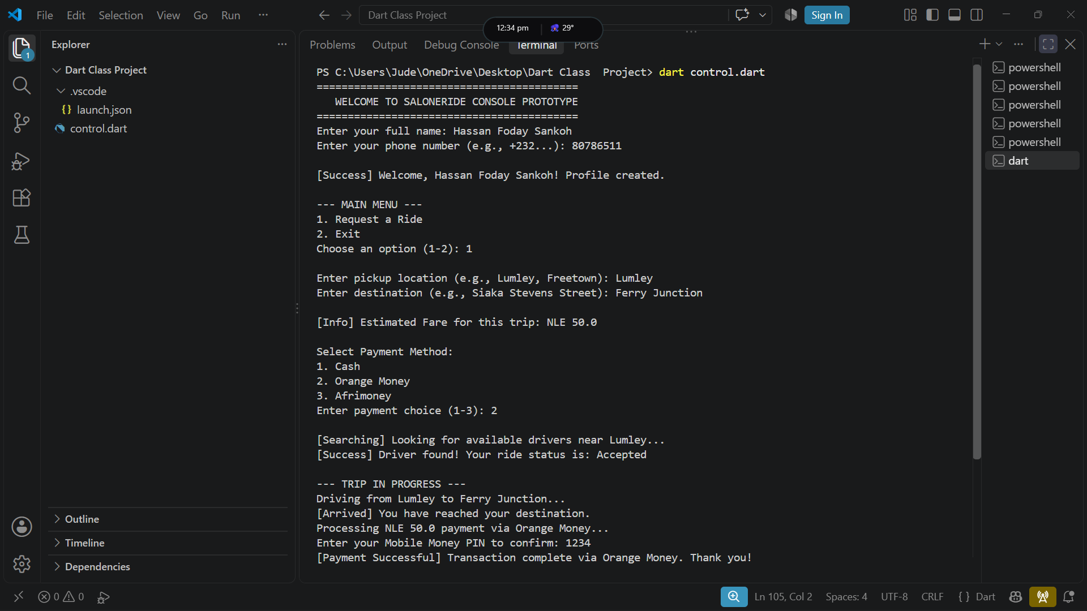
Figure 2: Pick Up list
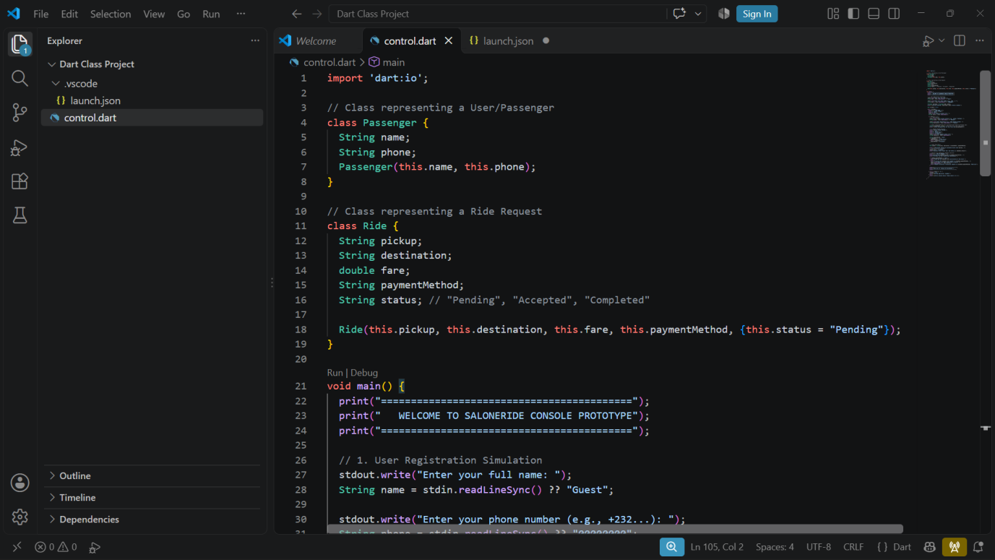

Figure 3: Mobile Money Payment Choice

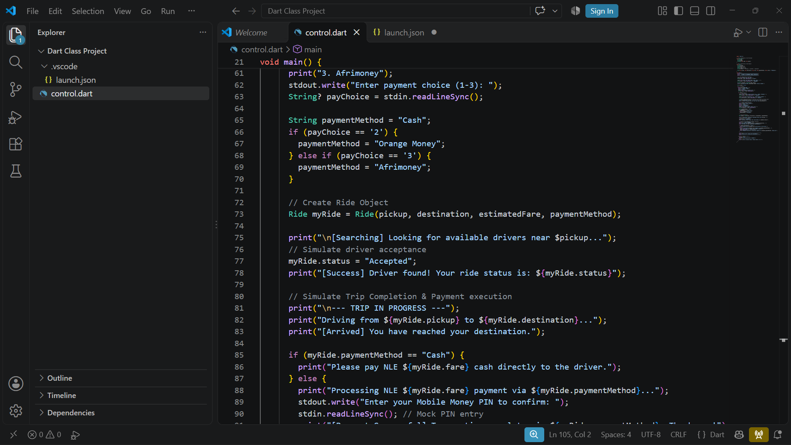
Figure 4: Mobile Money Payment Completed
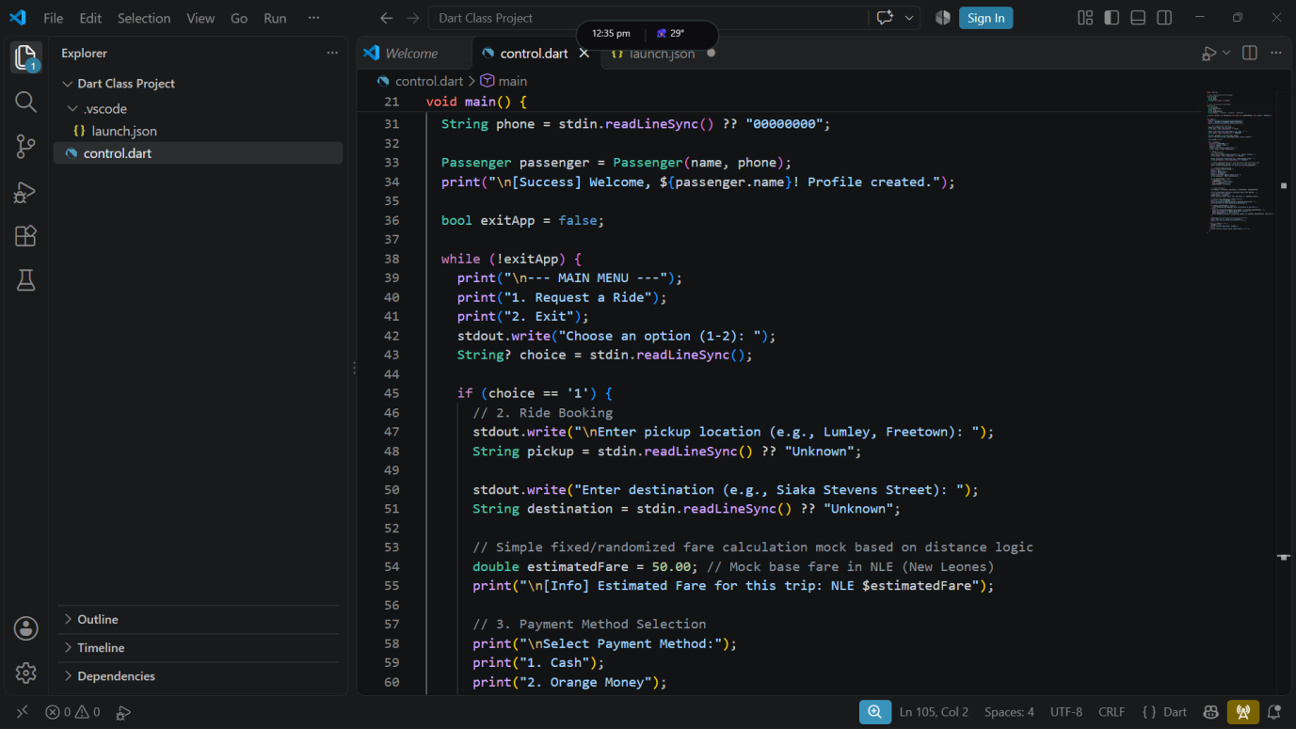

16. Explanation of the Program

16.1 Classes and Objects
A class is a blueprint for creating objects. The Passenger class has two fields, name and phone, and a constructor that sets them. The Ride class has fields for pickup, destination, fare, payment method, and status. When the user requests a ride, the program creates a Ride object from these values.

16.2 Constructor and Default Value
The Ride constructor takes the first four values as required positional arguments. The status is an optional named argument with a default value of Pending. This means a newly created ride starts as Pending unless a different status is given.

16.3 Input and Output
The program uses stdout.write to show a prompt on the same line as the user's answer and stdin.readLineSync to read what the user types. The null-aware operator ?? provides a default value (such as Guest) if no input is available. The print function displays messages, and string interpolation with a dollar sign inserts variable values into text.

16.4 Loop and Conditions
A while loop repeats the main menu until the variable exitApp becomes true. Inside the loop, an if / else if / else chain checks whether the choice is 1 (request a ride), 2 (exit), or something else (error message). A second chain selects the payment method, and a third decides whether to show the cash instruction or the mobile money PIN prompt.

16.5 Simulation
Driver search, trip progress, and payment are simulated with fixed messages. The status is set to Accepted directly, and the PIN is read and then ignored. This keeps the prototype simple while showing the order of events in a real system.

16.6 Limitations
The prototype has no input validation for empty text, a fixed fare, no real drivers or payments, and no storage. The Completed status is mentioned in a comment but never set. These limits are acceptable for a console demonstration but must be addressed before real use.

17. Limitations and Future Improvements

17.1 Current Limitations
- Data is stored only in memory and disappears when the program ends.
- The fare is fixed and is not based on distance or time.
- Driver acceptance is always automatic.
- Mobile money payment is only simulated, and the PIN is typed visibly and not used.
- Empty names, phone numbers, and locations are accepted.
- Any payment entry other than 2 or 3 is treated as Cash without a warning.
- Ride status never reaches Completed.
- There is no trip history, receipt, cancellation, or rating.

17.2 Future Improvements
- Create a Flutter mobile application for passengers and a separate one for drivers.
- Add input validation for names, phone numbers, and locations.
- Calculate fares from distance and time using a map service.
- Match each request with a real nearby driver who can accept or decline.
- Integrate with an approved mobile money payment provider; never store PINs.
- Store passengers, drivers, and rides in a secure database.
- Add Completed status, trip history, receipts, and ratings.
- Add safety features such as trip sharing and emergency contacts.
- Add authentication and protect personal data.

18. Conclusion
This report identified a problem in passenger transport: informal ride arrangements give passengers no advance fare, no booking confirmation, and limited payment choice.
SaloneRide is proposed as a software solution that lets a passenger create a profile, request a ride, see an estimated fare, choose between cash, Orange Money, and Afrimoney, and receive confirmation that a driver has accepted. The functional requirements describe what the system must do, and the non-functional requirements describe the quality expected from the prototype and future versions.
The Dart console prototype demonstrates the core booking and payment flow using two classes, a menu loop, and simulated driver and payment steps. The test plan in Section 14 and genuine screenshots in Section 15 should be completed before submission. The fixed fare, missing validation, and simulated payment are important limitations. A future Flutter application with maps, real drivers, and a secure payment provider could extend SaloneRide into a complete ride-hailing service.

19. References
- Assignment brief: PROG 202 - Software Engineering, Assignment 1, Limkokwing University of Creative Technology, Sierra Leone. Use the exact publication details from the brief if your lecturer requires a formal reference.
- Dart documentation: https://dart.dev/ - consulted for language syntax, classes, and running Dart programs.
- Only include sources you actually consulted, and cite any payment provider or transport policy documents you use.

